Technical Architecture:

Project Design Phase-II Technology Stack (Architecture & Stack)

|  |  |
| --- | --- |
| Date | 15 October 2022 |
| Team ID | PNT2022TMID06544 |
| Project Name | Car Resale Value Prediction |
| Maximum Marks | 4 Marks |

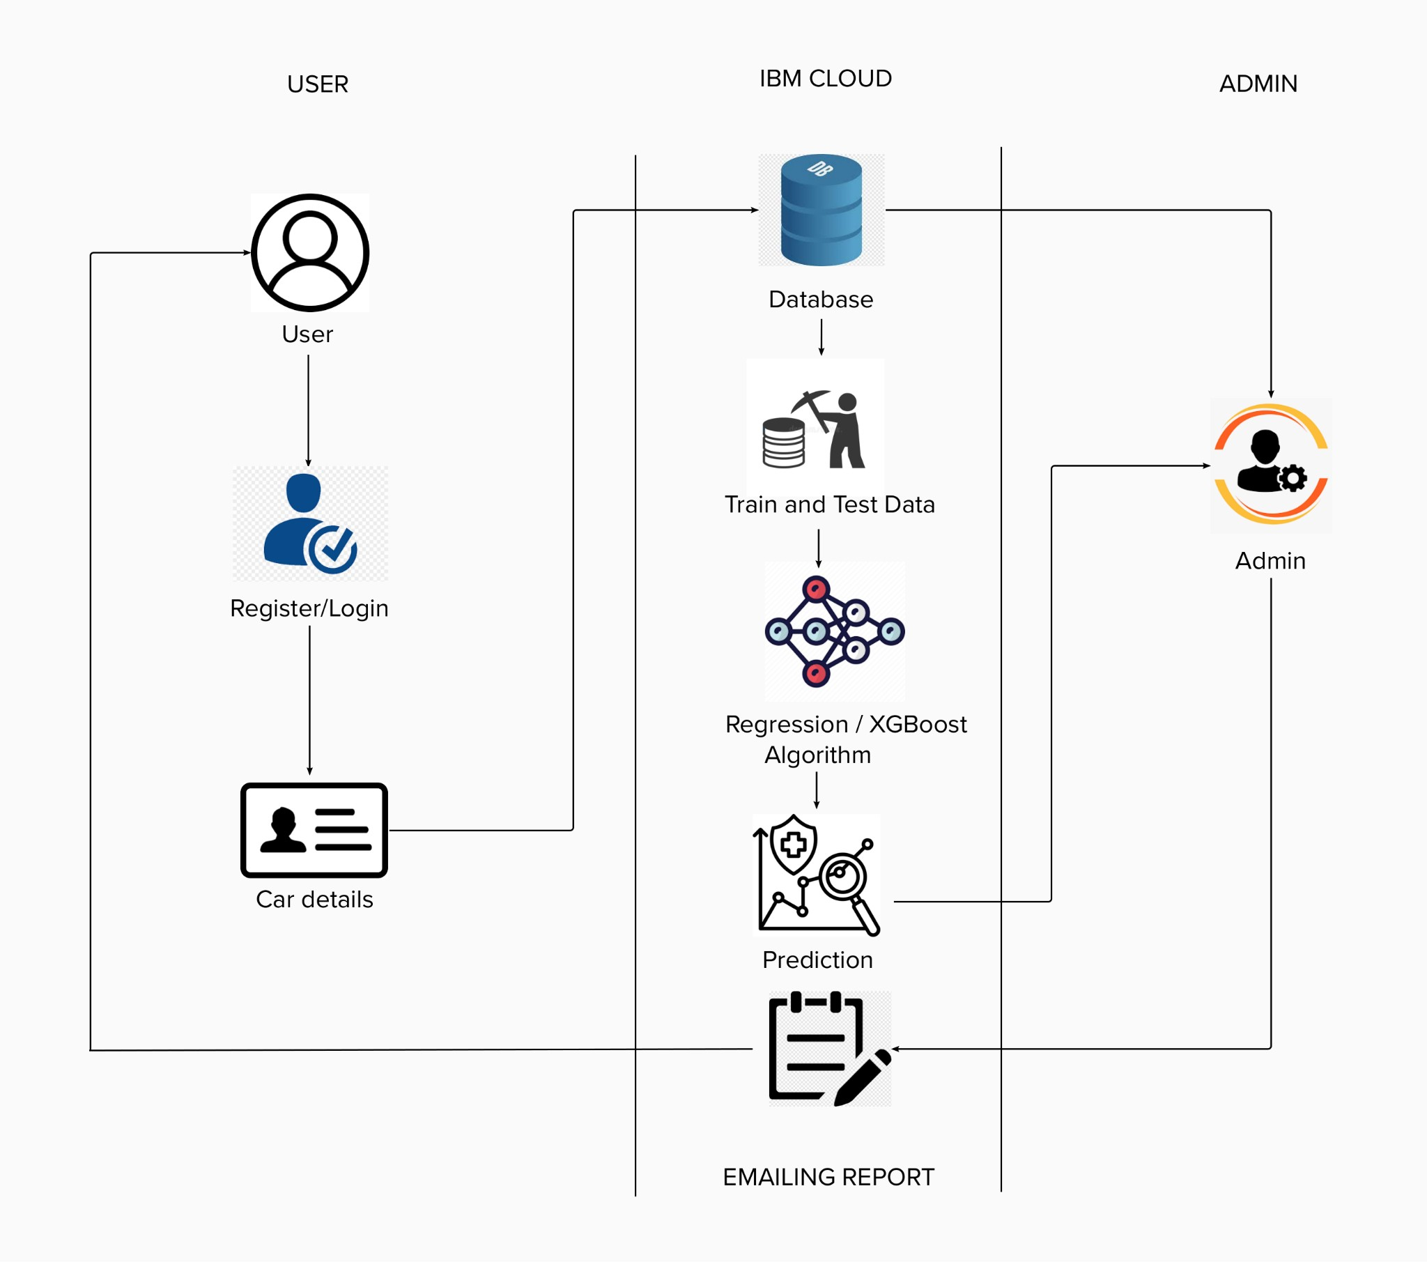

Table-1 : Components & Technologies:

|  |  |  |  |
| --- | --- | --- | --- |
| **S.No** | **Component** | **Description** | **Technology** |
| 1. | User Interface | The user interacts with application using Web UI. | HTML, CSS, JavaScript , ReactJS etc. |
| 2. | Database | The dataset containing car details is used for  training the model to predict the rate. | Python libraries like numpy, pandas etc. |
| 3. | Cloud Database | The dataset is stored in the IBM cloud | IBM Cloud |
| 4. | Machine Learning algorithms | The machine learning algorithms are used to predict the used cars rate. | XGBoost or Regression algorithm |
| 5. | Chart | The user will receive the prediction chart | SMTP |

Table-2: Application Characteristics:

|  |  |  |  |
| --- | --- | --- | --- |
| **S.No** | **Characteristics** | **Description** | **Technology** |
| 1. | Open-Source Frameworks | Open-source frameworks used | Python Flask, Python, IBM Cloud |
| 2. | Security Implementations | Authentication process implementation | Encryptions. |
| 3. | Scalable Architecture | Scalability of architecture consists of 3 tiers | Web server-HTML, CSS, Java script Application server-Python Flask Database server-IBM Cloud |
| 4. | Availability | The user can access through cloud | IBM Cloud hosting |
| 5. | Performance | Multiple users can access the web application | IBM Load Balance |